JAVA TRAINIGN NOTES

# OOPS concept - PIE (Polymorphism Inheritance Encapsulation)

## Encapsulation – When fields of a class are restricted to be modified from outside of the class to ensure the security.

### For Example

### Problem

Employee fields are public and any one can modify them from outside of the class.

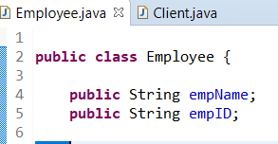

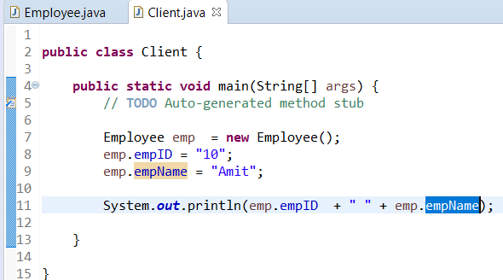

### Solution – Encapsulation

Make the field of class Employee private and put the getter and setter methods to modify them from anywhere outside from the class.

Advantage – This gives the full control to the class to restrict the access in setter method.

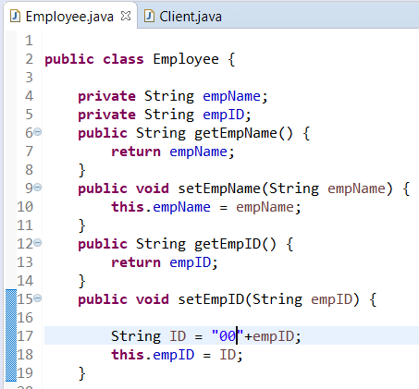

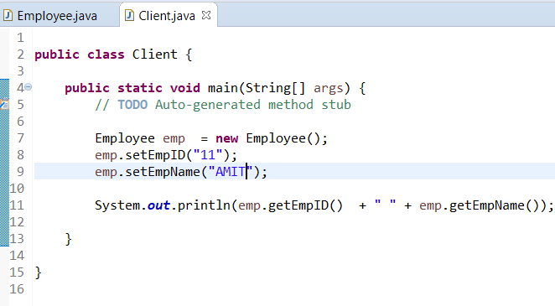

## Final keyword

If a **variable** is declared final then once initialized, it cannot be changed

If a **class** is declared final, then it cannot be inherited

If a **method** is declared final, then it cannot be overridden.

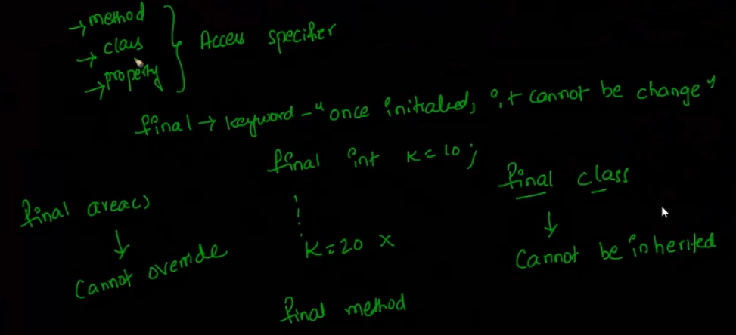

A class object can also be made final but you will still be able to change its data value as on objects final works on reference level not on value level.

Final Employee e1 = new Employee();

Employee e2 = new Employee();

E1.setID(50);

E1.setID(100); --this is possible as in objects final works at reference level not on value level.

E1 =e2; – not possible as e1 is final

## Static keyword

Static **variables** belong to class not to the objects. They can be invoked using class name and remain same for all the objects of the class.

Static **methods** are also belonging to class and can be invoked using class name.

When to declare something static final – when it must be shared across all the instances and value should never change once initialized

## Explain **public static void main ()**

This is the entry point of any program. It is public because it must be accessed by javac.

It is static because when java invoke the program, no object is created by that time. Hence being static only this method is invoked at class level.

It is void as you cannot return any value to JVM.

Main () is the signature. It cannot be changed as JVM will not know which method to invoke then. Hence nothing can be changed in this signature

# Inheritance

This is to re-use of the functionality and to avoid duplication of the code.

Use inheritance when you see “is a ” relationship between 2 classes.

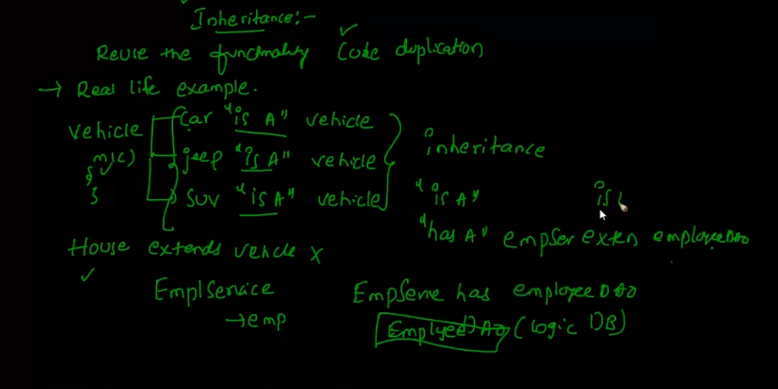

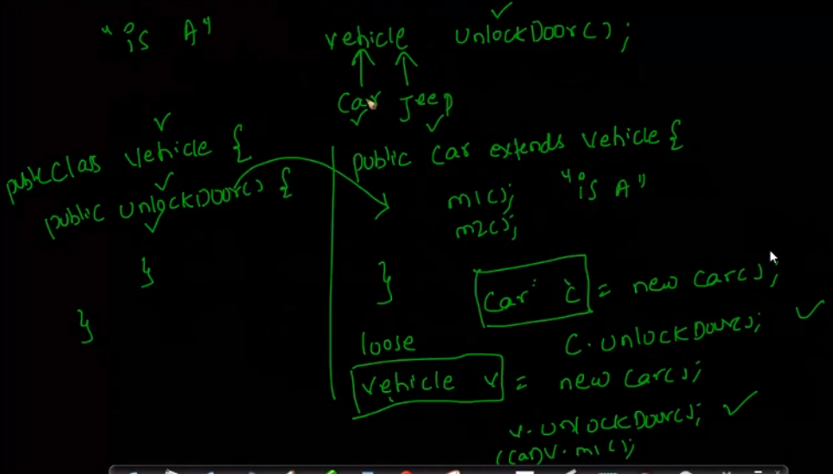

## “Has a” relationship

When we have an object reference of different class (Class B object reference) in our class A.

Then we say that A has a b.

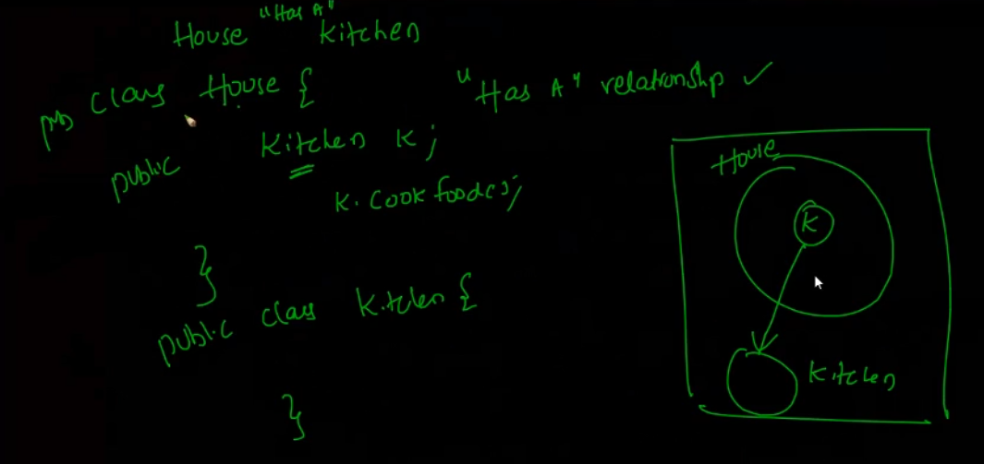

## Abstract keyword

If a class is declared abstract, then it cannot be instantiated.

If a method is abstract in a class, then we will have to declare that class as abstract

An abstract class should have at least 1 implemented method which can be used by the inherited child classes. Rest of the abstract method of super class, all the child classes must implement

If all the methods of a class are abstract, then that become interface.

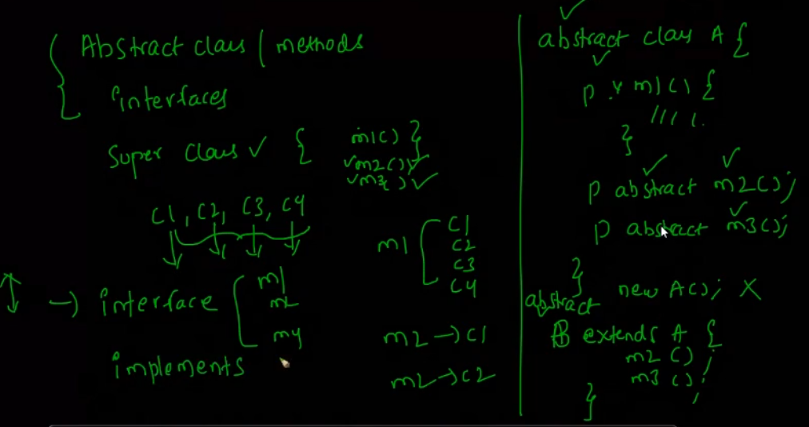

**When to use abstract class and when to use interface**

If child classes going to use same functionality then put that functionality in a method of an abstract class and inherit it.

If that implementation changes frequently then go for interface.

If all the child class have same behavior but with their own implementation, then go for interface. Like Vehicle-> Car, jeep,SUV example

# Data Types

## String

String is immutable means once initialized cannot be changed.

JVM holds the Pool of String.

If String s = “harish” 🡪 here jvm creates the object based on value and give the ref to s.

If we do k=”harish” 🡪 the it will not create the new object and give one more ref k to the same harish.

If s=s+”india”🡪 here’s will start ref to the new object harishindia and the value old “harish” will become unreferenced in pool.

0 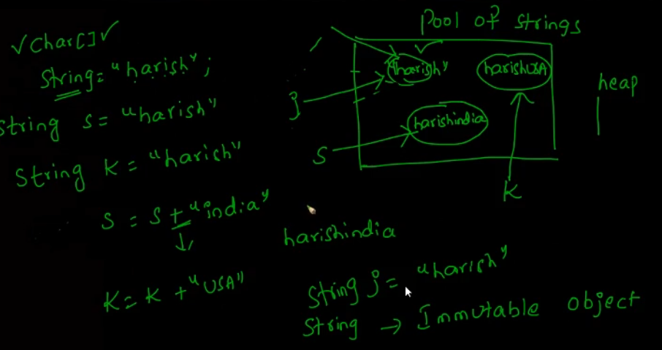

# toString() method

If we are going to do the SOP on any object (i.e. Java defined class or user define class) be it a String class object of the User defined class say Employee e.

Java always check the toString() method internally. If it finds it then it print whatever is defined over there if not then it goes to the Object class toString() method and print the CLASSNAME@hashcode as defined in method example EMPLOYEE@312654351

**So always remember to override the toString method in your user defined class.**

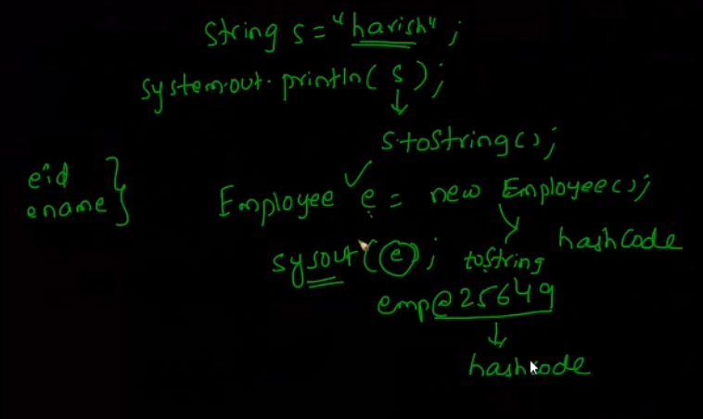

## Equals() method

Equals and toString are the methods of Object class. So we have to override them in our customized class.

O1.equals(O2) check the value of the objects.

O1==O2 check the reference of the objects.

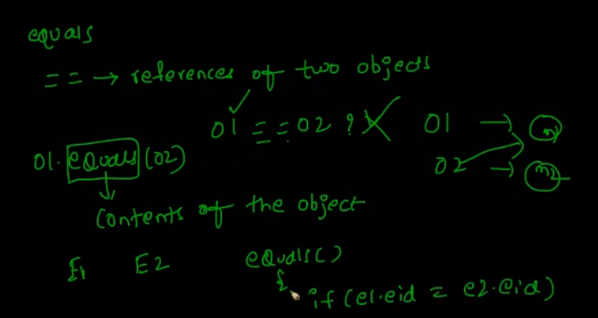

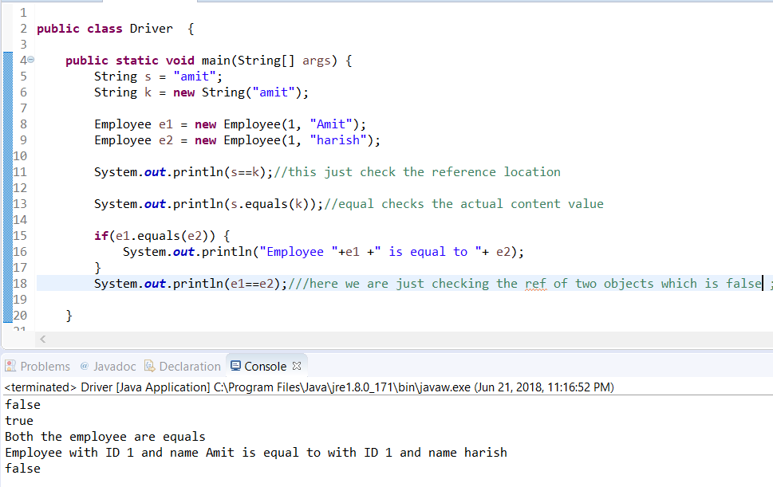

# Exceptions

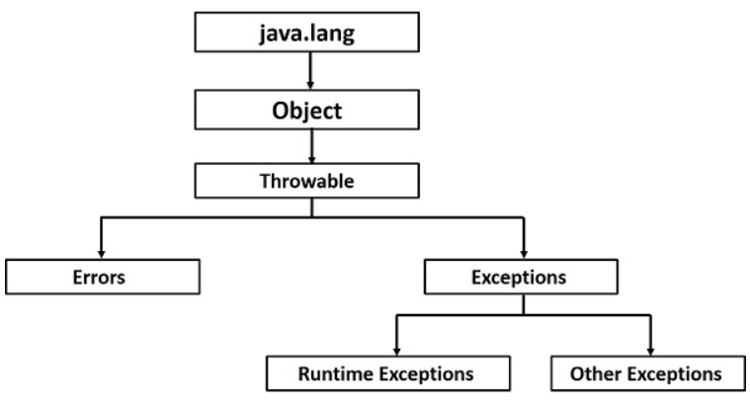

There are 2 types of exceptions compile time and runtime exceptions.

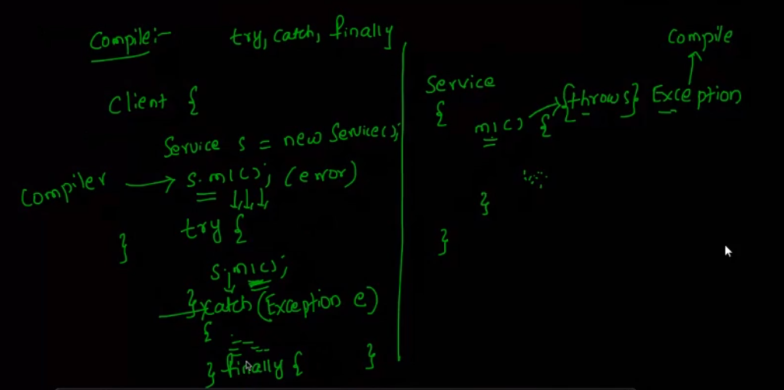

## Compile time Exception (Checked exception)

In Compile time exception, to throw an exception inside a method we use **throw keyword.**

And to indicate that method is going to throw an exception we append the method with **throws keyword**

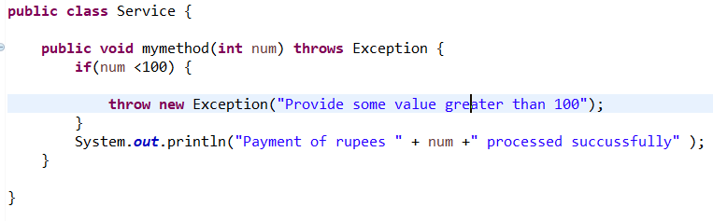

Now it’s the responsibility of the caller to catch the exception of this method or throws it to the next caller.

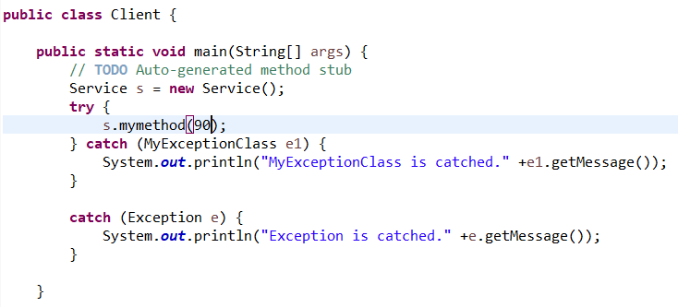

If we don’t want to catch the exception, then we can make main method to throws it to JVM.

JVM will handle it

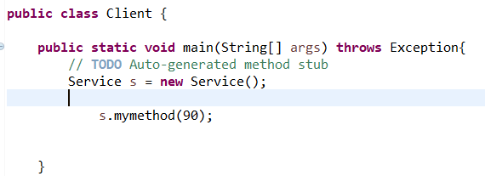

User Defined exception class.

User can also define their own exception class by extending the Exception class like below.

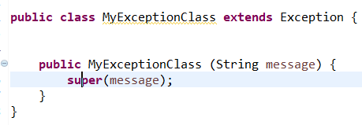

Other class can you this user exception class just as the Exception class like below.

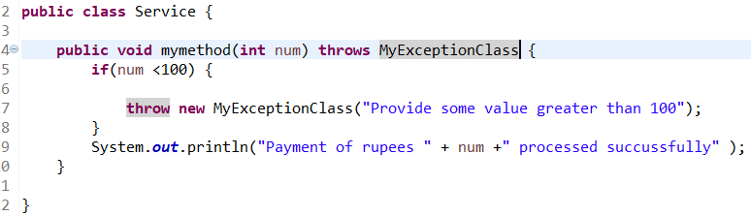

## Finally Block

Finally block always gets executed no matter exception occurs or not. This is used to release the resources or close the connections. This is put after catch block.

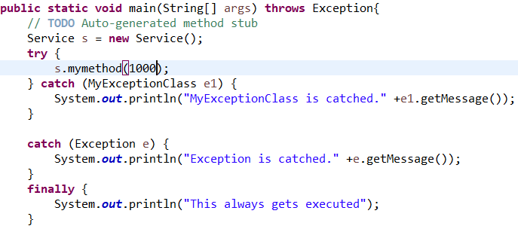

# Runtime Exception

It’s always preferred to use runtime exception to avoid cluttering of code.

**If catching an exception and write our own logic in that is not required, then always go for Runtime exception.**

**Here we don’t through the exception and don’t catch them as it is done by JVM.**

**Finally block can still be used in Runtime exception like below (notice no catch block due to above reason.**

**Try {**

**}**

**Finally {**

**}**

**Check below how cleaner the code is. Always use runtime exception if you want the program to exit by the JVM in case of exception occur.**

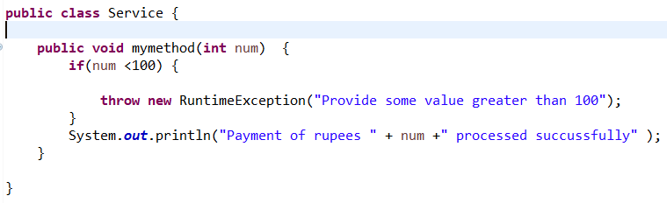

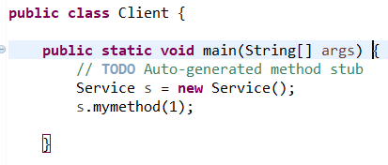

# Try-with-resources updates (post Java 7)

Prior to java 7, we used to use finally block just to close the resource’s. (All the IO objects act as resources and need to be closed)

Now we can create the object of that resource as parameter in try block...and once the try block is executed ...resource will be closed.

public class Java7ResourceManagement {

public static void main(String[] args) {

try (BufferedReader br = new BufferedReader(new FileReader(

"C:\\journaldev.txt"))) {

System.out.println(br.readLine());

} catch (IOException e) {

e.printStackTrace();

# Caching Multiple Exceptions by single catch (post Java 7)

Rather than catching multiple exceptions in different catch block. We can club them into one like below

catch(IOException | SQLException ex){

logger.error(ex);

throw new MyException(ex.getMessage());

}

# Data Structures Algorithm

## Before using the collection, we need to understand the time and space complexity of a program.

### **Time and Space complexity**

Time complexity is how much time this program going to take to execute and space complexity is how much diskspace this program going to take in disk.

Time and space complexity is represented by below 3 signs.

In below program, time complexity is O(N) -> where N is the input .it means this program is going to take N iteration to execute the whole program.

Space complexity is O (1) as we are just going to take 2 variable constants here

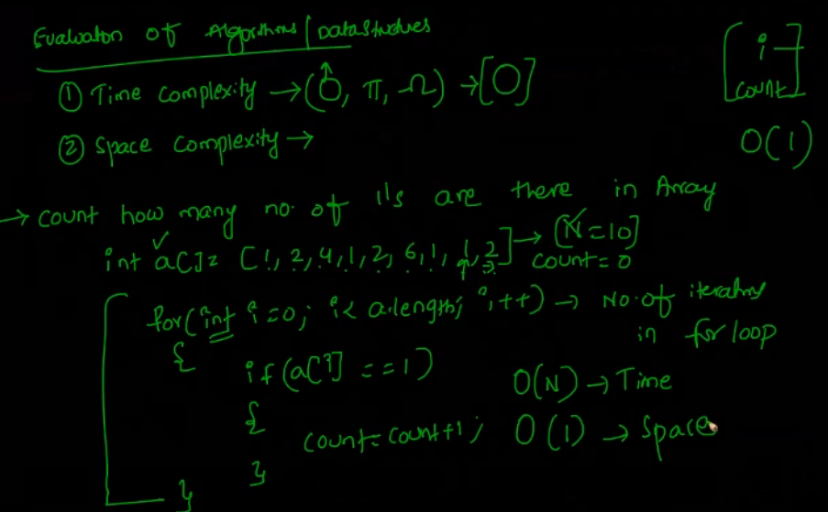

## Calculating time complexity

For a problem where we have single loop iteration, the time complexity would be O(N) where N is the input which defines the iterations.

If we have 2 loops, then the iteration would become N*N = N Square.

So, the time complexity would be O (N square)

Now O(N) < O (N square)

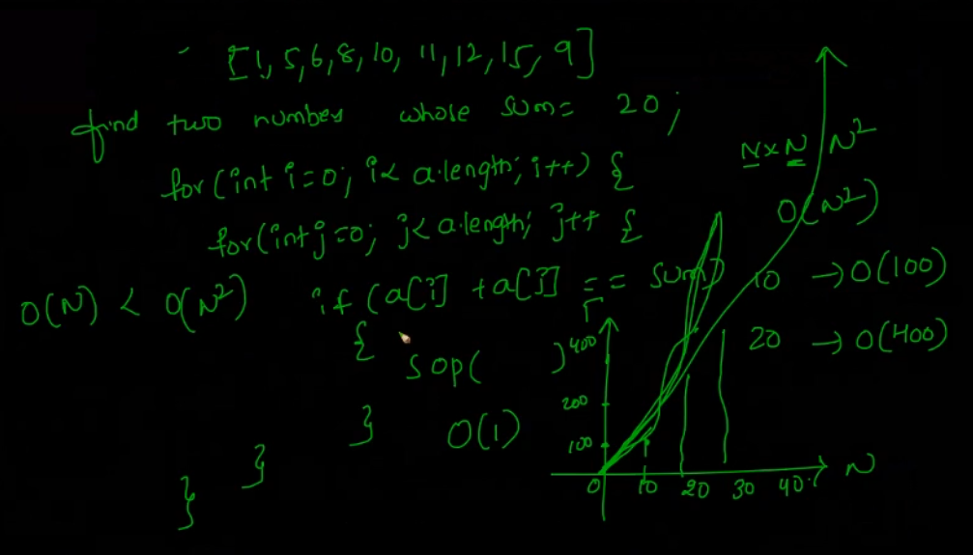

So as the input increases, it directly increases the iteration.

Now we can further decrease the time complexity using binary search

Binary Search – If we have a collection of multiple sorted array then we take the median of that collection first with the help of below formula.

Median = (lower index+higher index-lowerindex)/2 i.e 0+6/2 = 3

Suppose we have a problem where we must find number 12.

So, with this formula we get 4th index which is a [3].

Now check if a [3] < 12 if yes then out number will def be in right side.

So again, we take the median of the half right side

Now the median would be = 3 + (6-3)/2 = 4

Now again repeat the above logic and check in if condition

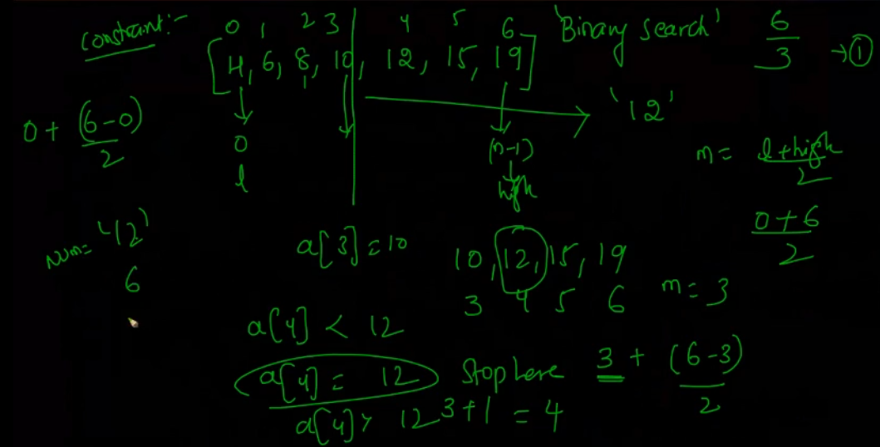

So, based on the formula of binary search we can derive the below.

If we have input array of 8 then number of steps to iterate is 3 this can be written as log 8

So, if we N number of input then it would be log N to the base 2

We can find the number of iteration with the help of log N as below.

So, the time complexity would be O (log N)

O (log N) < O(N) < O(N*N)

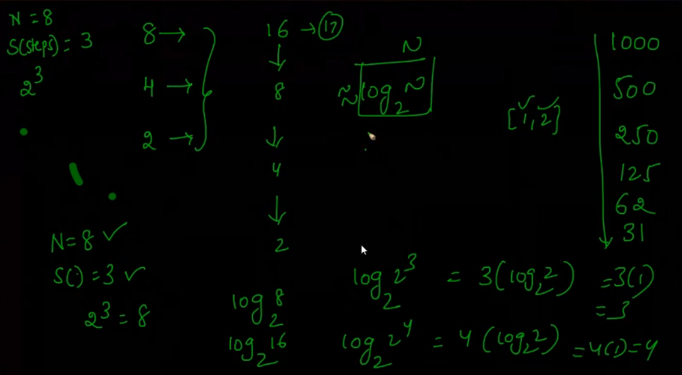

## Binary Search Program

**package** amit;

**import** java.util.Arrays;

**import** java.util.Scanner;

**public** **class** BinarySearch {

**public** **static** **void** main(String[] args) {

Scanner in = **new** Scanner(System.***in***);

System.***out***.println("Please provide the size of the Array");

**int** n = in.nextInt();

**double**[]array = **new** **double**[n];

System.***out***.println("Please provide the values of the array");

**for** (**int** i = 0; i<n; i++) {

array[i]=in.nextInt();

}

Arrays.*sort*(array);

**for** (**int** i=0; i<array.length; i++) {

System.***out***.println("Values sorted" +array[i]);

}

System.***out***.println("Enter value to be searched");

**int** searchNum = in.nextInt();

**int** low = 0;

**int** high = n-1;

**int** median = 0;

**while** (low<=high) {

median = low+(high-low)/2;

System.***out***.println("Low is ---> "+ low);

System.***out***.println("high is ---> "+ high);

System.***out***.println("median is ---> "+ median);

**if** (searchNum == array[median]) {

System.***out***.println("Value is found at location index "+ median);

**break**;

}

**else** **if** (searchNum < array[median]) {

high = median-1;

} **else** **if** (searchNum > array[median]) {

low = median+1;

}

}

**if** (low>high)

{

System.***out***.println("value is not in array");

}

}

}

# Collections

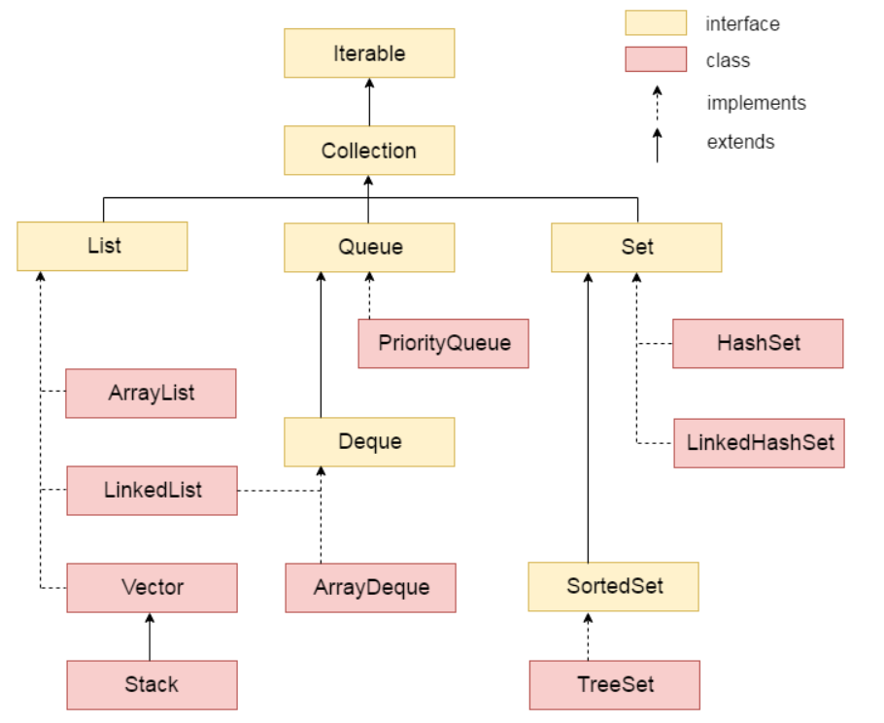

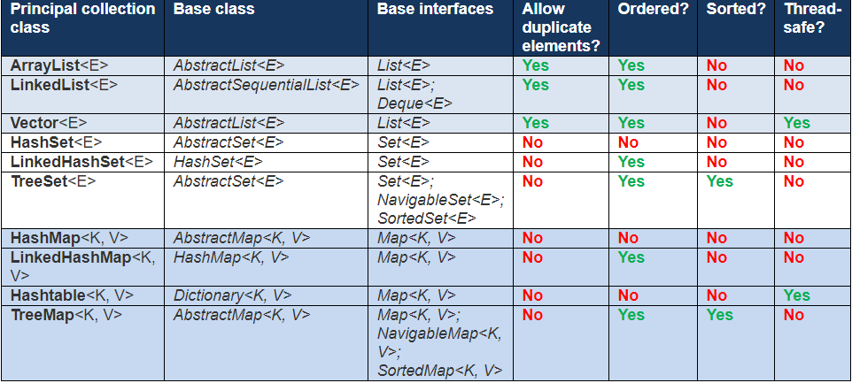

## Arrays

Arrays are fixed sized same data type collection where the length is defined at the compile time only.

The disadvantage of arrays is that they cannot grow dynamically. So, we have arraylist.

The implementation behind the arraylist is given below.

Declaring array of length 5

Int arr [] = new int [5];

Declaring array with value

Int arr[] = {1,2,3,4,5};

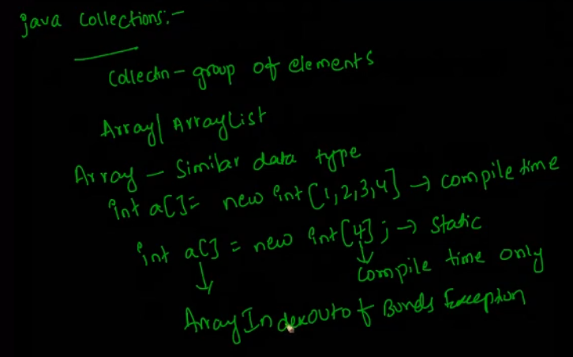

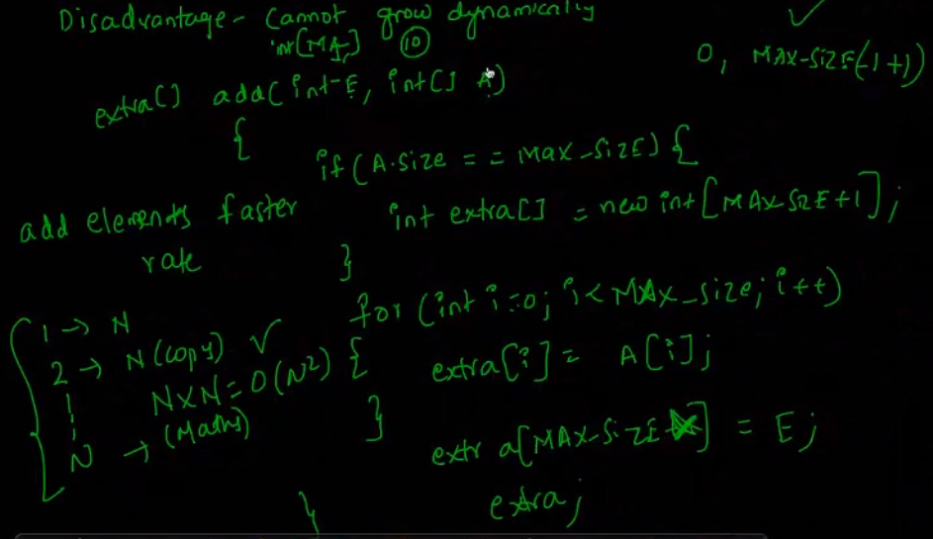

# ArrayList

This is ArrayList extends the List interface.

ArrayList class can contain duplicate elements.

ArrayList class maintains insertion order.

ArrayList class is non-synchronized.

ArrayList allows random access because array works at the index basis.

In Java ArrayList class, manipulation is slow because a lot of shifting needs to be occurred if any element is removed from the array list.

# Linked List

Linked list is used when we must manipulate the elements in the list.

Each node in the linked list store the value and the address of the second node.

So, the insertion/deletion is quick, but the searching of the element is time consuming because for that it must iterate through all the elements

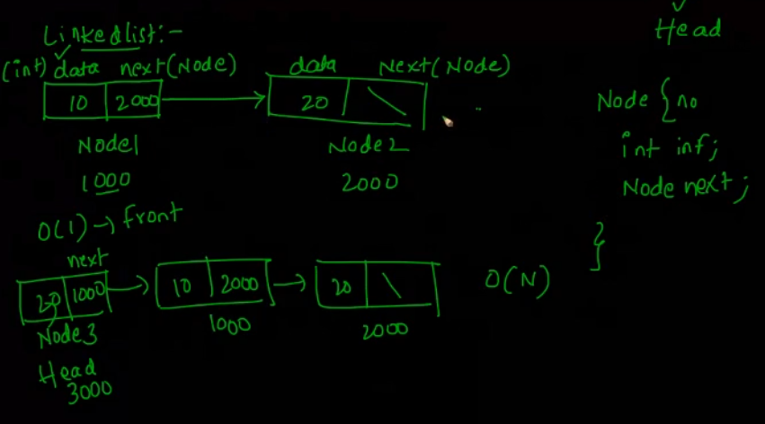

As manipulation in the arraylist cause the performance issue as the time complexity is O(N). (this is because it must shift the arraylist elements N times to perform any updation/deletion.)

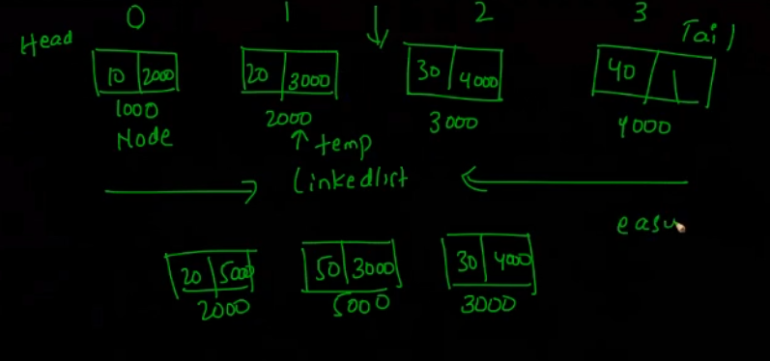

**Array List** – This is fast and good for searching the elements as it uses indexes for that.

**LinkedList** – This is fast and good for manipulating the elements inside it

Lists are not thread safe (arraylist or linked list). To ensure thread safety, we can ether put them in synchronized block or we can make use of syncronizedList (List <T>) method from the collection util class.

**HashMap** – this is created to have the best of both (i.e.: arraylist and linkedlist)

# HashMap

HashMap is the implementation class of map interface. It works on key, value pair mechanism

Hashmap provide the best time complexity which is O (1) on average.

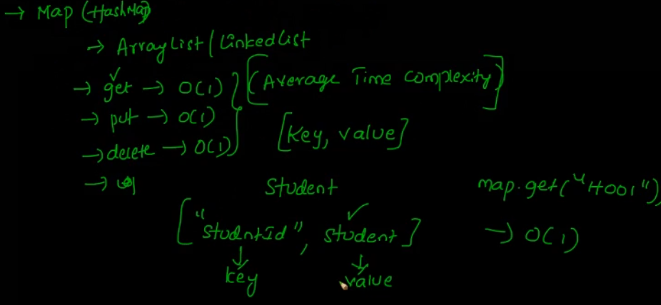

When we say map.put(key,value), then it creates the hashvalue based on the hashcode(this default value we get for all the objects as it is provided method in object class.

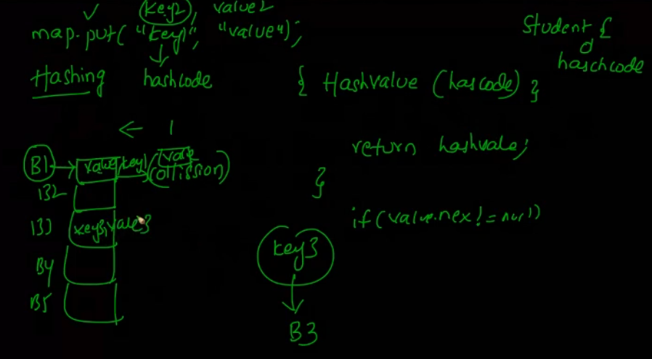

**Important point to remember about hashmap.**

* Always define the max-size (based on idea, this is like initial capacity in arraylist) while creating the hashmap. It will avoid from frequent rehashing.
* Define your own load factor like (0.75). means when the load reaches the 75% of the max. it goes for rehashing to increase the hashmap size.
* Map keys should be unique and immutable objects (means once initialized they should not be changed)
* Whenever any put or get method is invoked on map, following approach is followed

Get (key)->hashcode->hashvalue->bucket (say B0)-> get value using binary or linkedlist method from that Bucket.

* Same is followed to put some value in hashmap.
* **Before creating a hashmap for any entity class (like employee, student etc) always override the equals() and hashcode methods. Hashcode is required because when we do map.get(key) it takes us to the bucket (as explained in above point) now it’s the responsibility of the equals()method to search and check the key in that bucket array.**
* **Two different object can point same hashcode so the deciding factor would be equals method. For example say the hashcode of abc=2*3*4 = 24 and say for bca = 3*4*2=24. Here is both the cases the hashcode is similar but the objects are different (i.e abc and bca) so we must override hashcode if we override equals.**

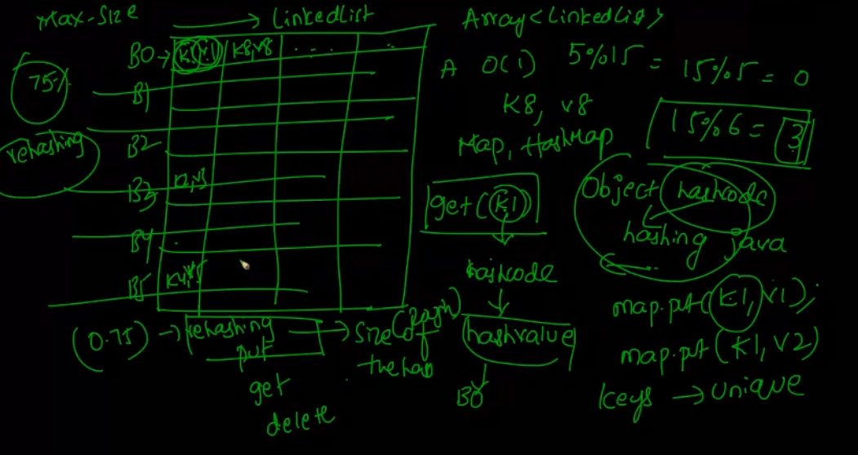

Why hashmap key needs to be immutable

If we have a student class and we have created a map using student object as key.

Student s = 10: //this is intialised .

Now if we do something like s.setname(“Amit”) , this means we are changing the student object and we might not be able to get the value which was put in a map using the original student key object.(as new object creates a new key)

Then map.put(s, School)

So already declare your entity class as immutable

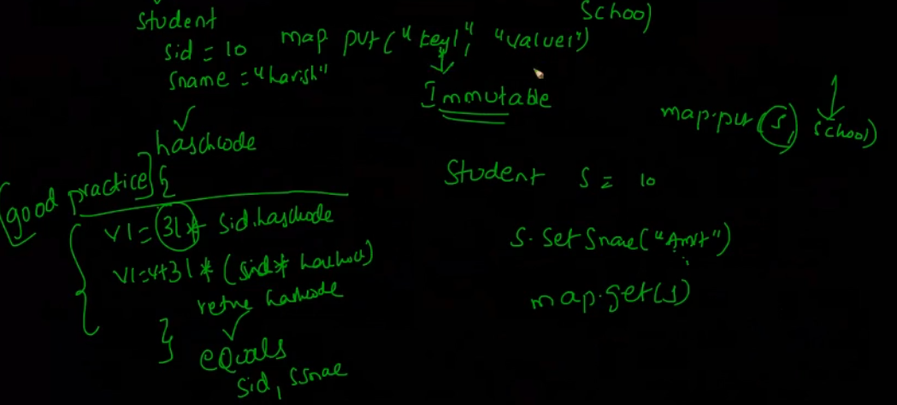

**How to make class immutable (immutable classes are used mostly in hashmaps)**

* **Make your class final (so that no one able to extend it)**
* **All class fields should be final.**
* **No setters. Only getters.**
* 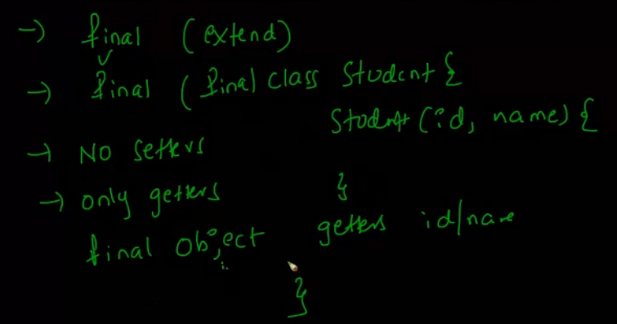

**HashMap –** No Thread Safe but fast.

**HashTable –** Exactly same as hashmap but it is threadsafe as they have made hashtable methods synchronized. **Drawback** - It is slow in performance as they have put method level synchronization.

**Concurrent hashmap –** This is threadsafe as well as fast because it provides 16 segments and 16 threads can access it parallelly which makes it fast. It has got 1 lock per segment.

# Equals and hashcode contract

**objects which are .equals() MUST have the same .hashCode().**

# Default implementation for equals() and hashcode() methods

@Override

**public** **int** hashCode() {

**int** hashValue = 31\***this**.getsID().hashCode();

hashValue = hashValue+(**this**.getsName().hashCode());

**return** hashValue;

}

@Override

@Override

**public** **boolean** equals(Object obj) {

System.***out***.println("helloooo");

**if** (obj == **null**)

**return** **false**;

**if** (!(obj **instanceof** Student))

**return** **false**;

Student s = (Student) obj;

**if**(!**this**.sID.equals(s.sID)) {

System.***out***.println("Sid is " +**this**.sID);

**return** **false**;

}

**if** (!**this**.sName.equals(s.sName)) {

System.***out***.println("hellllo");

**return** **false**;

}

**return** **true**;

}

Note - While checking the equality of 2 objects ( map.put method do it automatically), always pay attention to the over ridden hashcode. As for equal methods it always generate the same hashcode+ depend on the logic written in equals() method. In other words..if we are using 2 field in equals method then we have to you same fields in hashcode also…otherwise the hashcode will not be correct

**Important - If 2 fields are being used (say id and name) in the equal method, then both should be used to calculate the hashcode method.**

## How to Iterate in a hashmap

1. First way

Set <Integer> keys = map.keySet();

**for**(Integer i: keys) {

System.***out***.println("Key is "+i+" and value is "+ map.get(i));

}

1. Second way, Here Map.entry is the nested interface in Set interface.

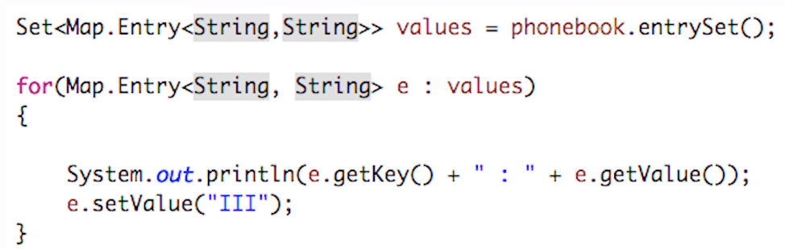

1. Third way is below
2. 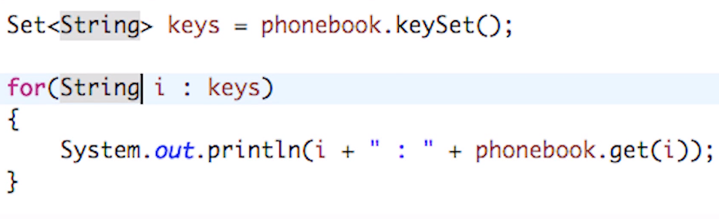

# Comparable Interface

This is used for sorting the objects. If we have a person class and we have to do sorting on the persons objects, Then make the person class implement the comparable interface and implement the compareto(Object o) method.

**Comparable example**

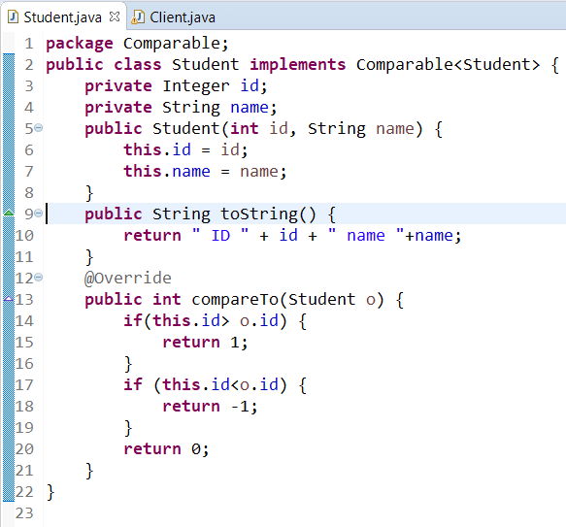

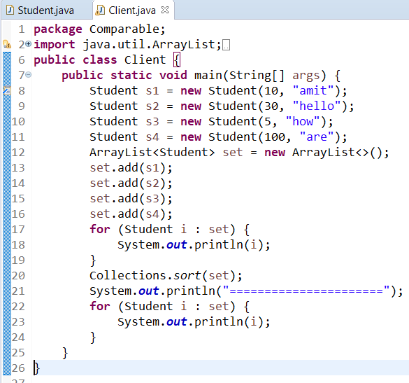

**Important – We can further include logic to compare method like if Id’s are equal then sort or names basis like below.**

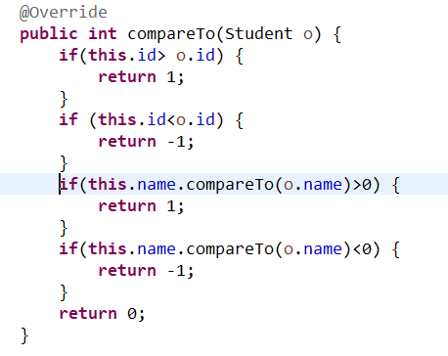

# **Comparator Interface**

If we want to change our sorting logic from ID to something else without changing our custom class, then we go for comparator. Comparator means more freedom to sort using a separate class. Create a separate class like below and implement the compare method.

**Note** – If you want to keep many sorting logics then we can create many individual comparator classes (like below we are using name to sort)

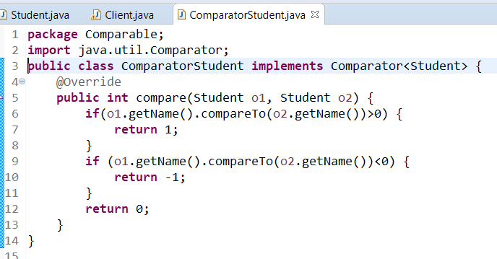

**If we want our client to use the comparator sorting logic, then make the collection use the comparator object for sorting as below.**

* **If we are using below approach, then client will not use comparable code logic.**
* **You can make any number of comparator classes based on different sorting needs**



# Heap and stack memory

## Stack Memory

Anything which is inside the method (starting from main method) goes into stack memory.

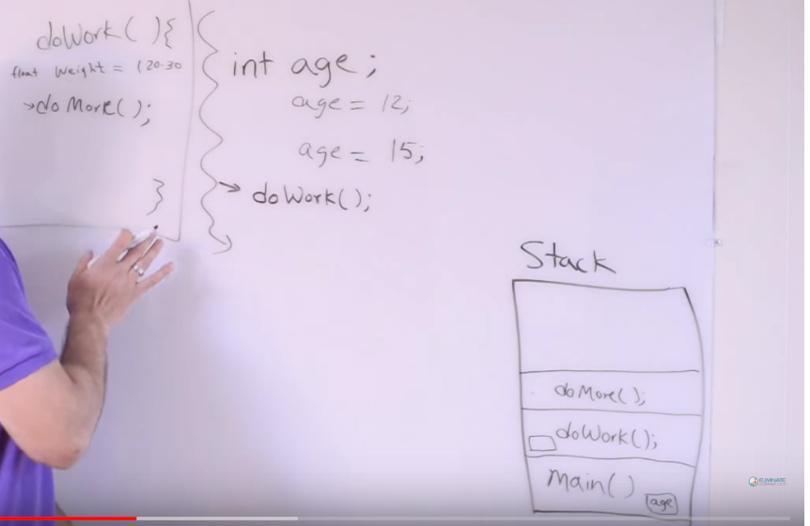

If we have a main method and it has got local variables and another method invocation, then it creates a block of main method inside the stack memory and allocate some space for local variables.

As different methods are invoked from main () method, then they go up in the stack and so on.

All the methods block starts getting removed from the stack, once their execution is finished and once main () method execution is finished, all the stack memory gets cleared and gets ready for another execution.

## Object creation inside the method (Stack memory – used by threads)

Method contains only the refence name of the object with its address inside the stack. Actual object stays in heap memory.

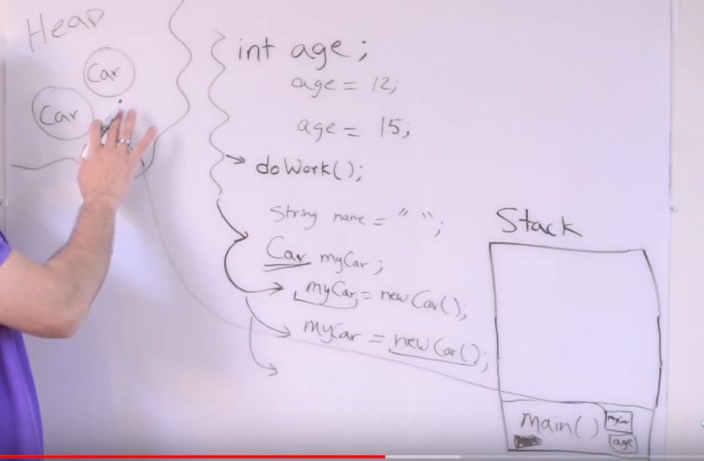

# Heap Memory

All the class level variables (Instance variables) also reside in objects in heap (as object share the instance variable so they contain their own copy of it.

Example: - If we have class Car and we have something like this

Public class Car {

Int a;

Engine e;

}

And if we are doing Car car1 = new Car ();

Car car2 = new Car ();

**Heap Memeory**

# Iterator (Use it if you want to remove some element in collection)

Iterator is used to iterate through collection. Main difference between iterator and for loop is when you try to remove some element in collection, for loop throws ConcurrentModificationException exception. But Iterator can remove it easily.

**Example**

Iterator<String> iter = l.iterator();

while(iter.hasNext()) {

System.out.println(iter.next());

}

# Threads

System Operating system run different processes in the system like chrome, notepad, msword, java etc. In order to run a process, OS need to assign some piece of memory from RAM to all these processes.

When OS allocate memory to Java processes, it is called as Heap(This contains the java objects).

To launch any Java program, we need to define min (-Xms 512m and max (-Xmx 1024m) heap.

-Xms 512m means program will only execute if OS provide the minimum 512mb memory to program.

-Xmx 1024m means program might reach max to use 1024 mb memory and after that it will throw OOM error.

In between, garbage collection also keep working to fee up the memory from unused object.

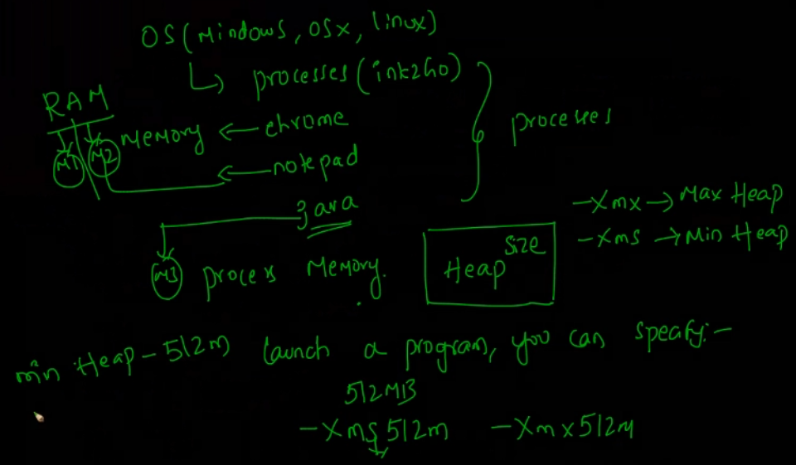

Since heap is assigned to java processes and all the threads are part of this process hence they also need to share the same heap space.

Hence the class level instances which reside in heap are not thread safe as they need to be shared across all the threads.

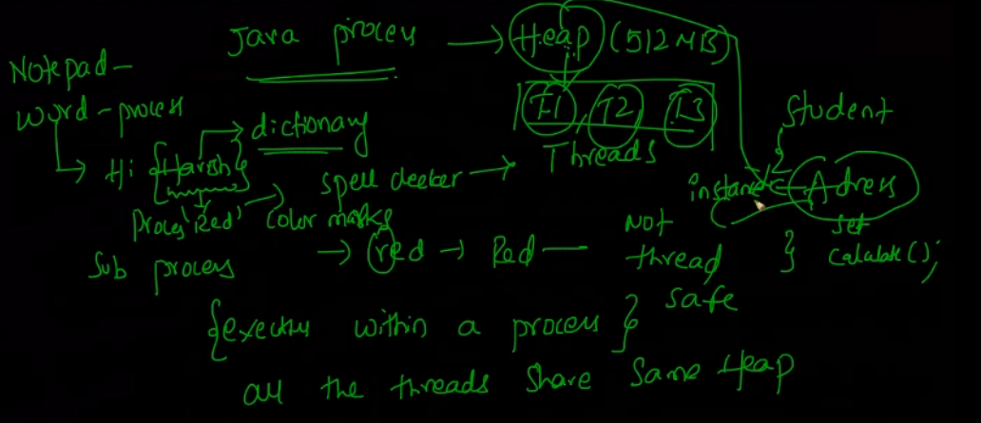

# Method level

If 2 threads are accessing some method m1() which is having some local variables, then T1 and T2 both will have their own stack where they maintain a separate copy of local variables.

So, methods are thread safe. If we are using the instance inside the method, then that particular line is not thread safe.

# Thread Practical

There are 2 ways of creating threads

1. Extend Thread class and override run method
2. Implement runnable interface and implement run method.

**Thread Implementation example**

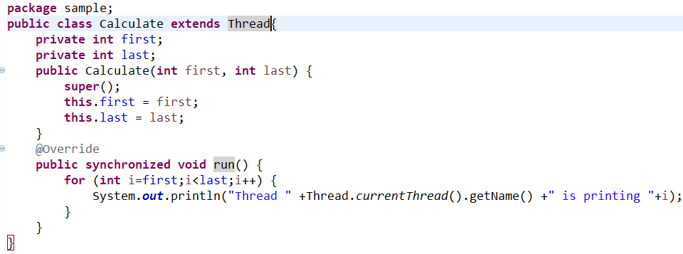

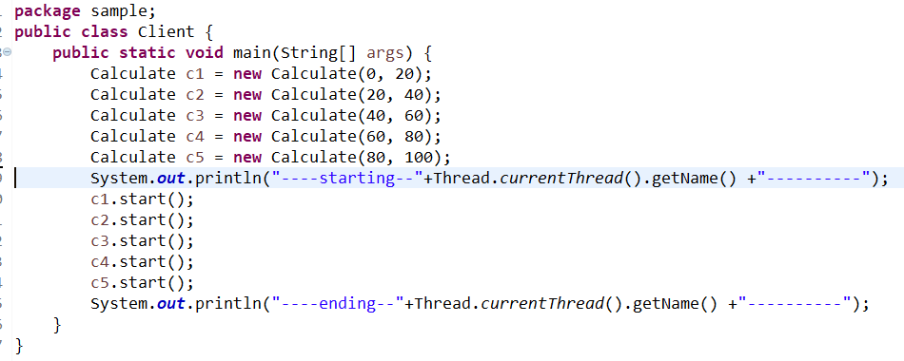

**Runnable implementation example**

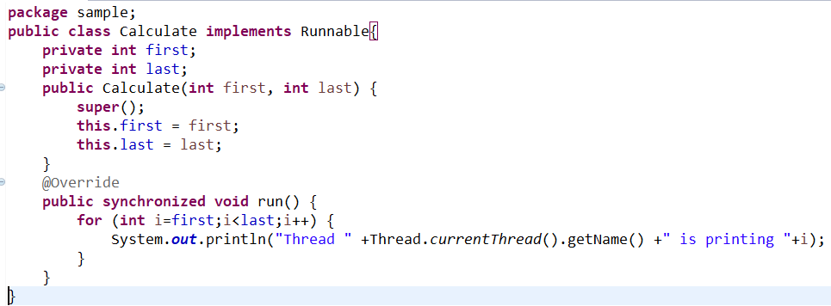

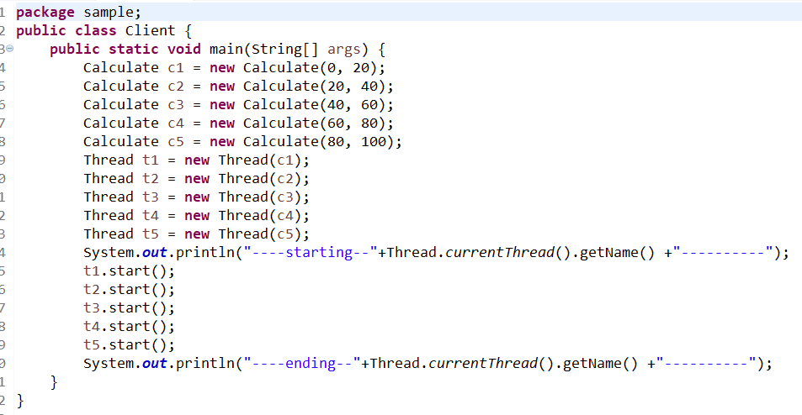

**Important points** – If we create different objects like above and run different threads for them, then we will get mixed results event if we have the synchronized block. (as synchronized put lock on object and here we are passing different objects hence all the threads can access this method at same time)

* To make the synchronized method access only one thread at a time, we need to make sure that all the calling thread share same object as shown below.
* 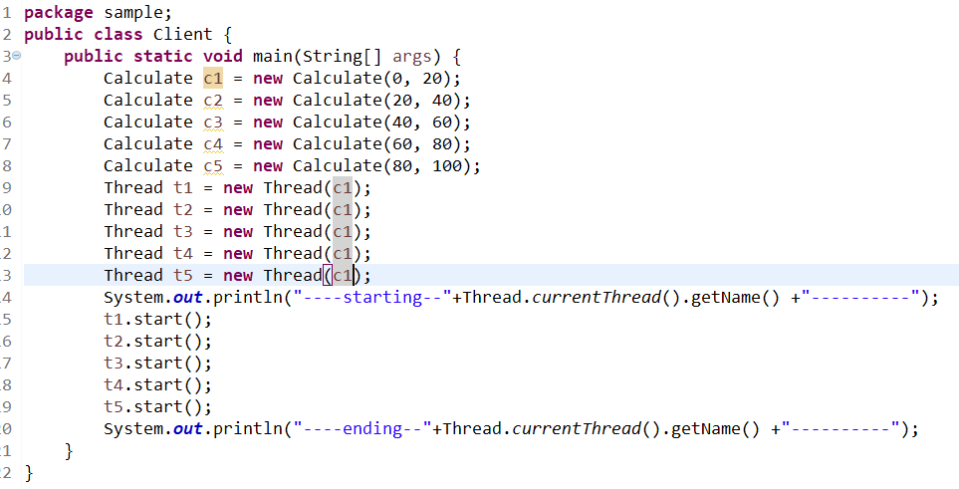
* Here all the threads using same c1 object hence the result will be in sequence thread wise order. (Means thread1 will finish first then thread 2 and so on)

# Synchronization

Most Important – When we think about synchronization we always think about the **object lock**

When we want to block many threads to enter any method or block and we only want one thread to finish the execution first and then release the object lock for another thread.

Synchronization are of 2 types

* Method level synchronization
* Block level synchronization

## Method level Synchronization

When we use synchronized keyword in method then it is called method level synchronization.

But drawback is the performance as it makes the execution slow.

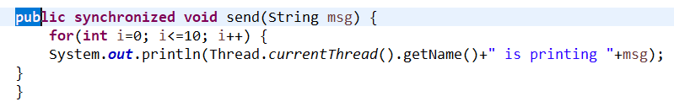

## Block level synchronization

When we use synchronized keyword for some code block.

This is preferable to use as it is fast, but we need to identify the exact code which is being shared and not thread safe.

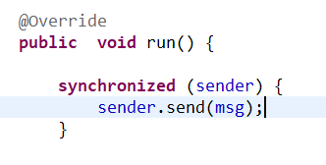

## Synchronization Example

When objects are being used in code then we need to make that code thread safe as these objects belong to heap and shared with all the threads.

Below example shows sender object needs to be synchronized as it is shared object.

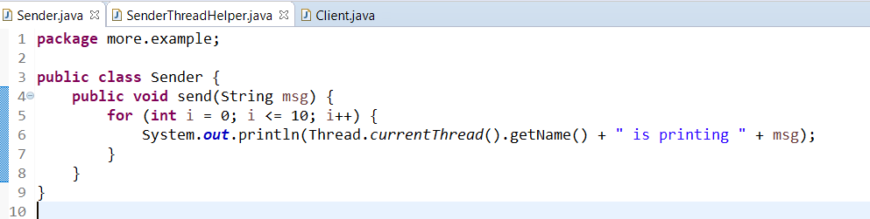

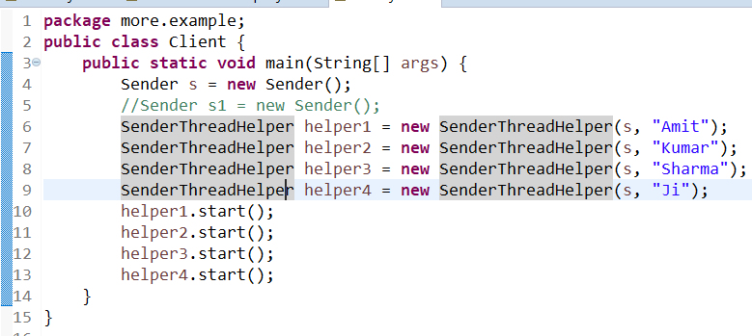

Below are the different outputs if we put synchronized block at different places

Scenario 1 - If we put synchronized at the method level as below, then it will show in consist result

Reason :- below method level synchronized acquire the lock on SenderThreadHelper object not on Sender object. Because it is not restricting multiple threads from entering send method.

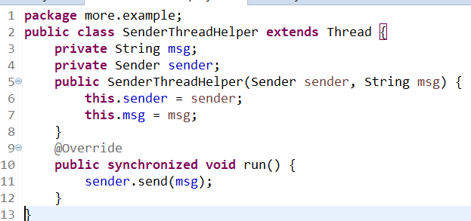

Scenario 2 - if we put it in synchronized block then it will **give correct consistent result** as we are passing sender object to get lock on it**.**

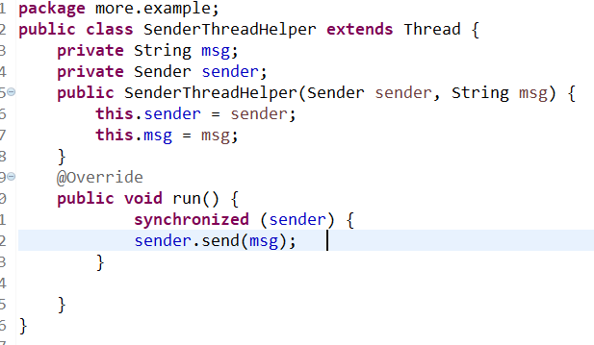

**Scenario 3** - if we put it in synchronized block then it will **give incorrect result** as we are passing this object which will give is the lock on SenderThreadHelper object as we are calling helper1.start();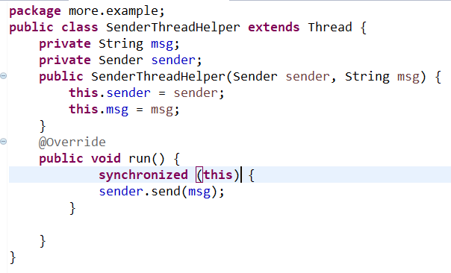

**Scenario 4: -** We can make the sender method as synchronized as it is in Sender class and will give correct results

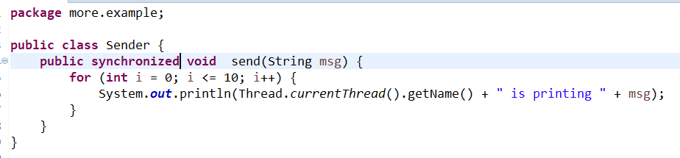

**Important point** – If we have 4 synchronized method in a class and we have 2 threads T1 and T2 calling m1 and m2 at the same time with lock on same object then they will not be able to enter the methods at the same time even though the methods are different**. This is because synchronization work on object level and object is lock here.**

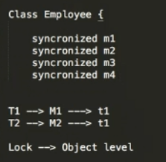

# Multi-threading consumer producer problem, wait() and notify()

Wait() – This is make the current thread wait until the other thread notify it to resume the work.

Like if we put wait in producer then it will wait till it get the notifyall signal from the consumer thread.

Like wise the consumer thread will wait until it gets the notify signal from producer.

**See the color combination below. Green wait will resume to work once it get the signal from green notifyall and same with other color.**

So, consider producer as thread 1 and consumer as thread 2

producer(){

Obj.wait();

///producer is doing some business logic here

Obj.notifyall();

}

Consumer(){

Obj.wait();

///consumer is doing some business logic here

Obj.notifyall();

}

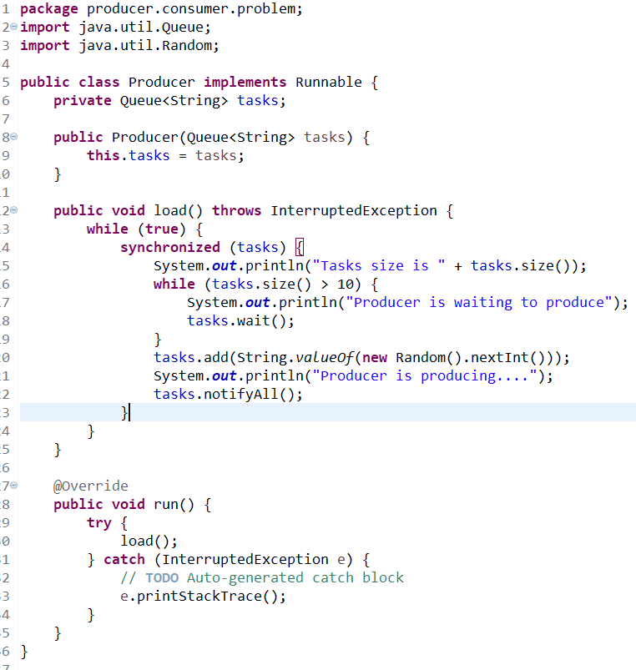

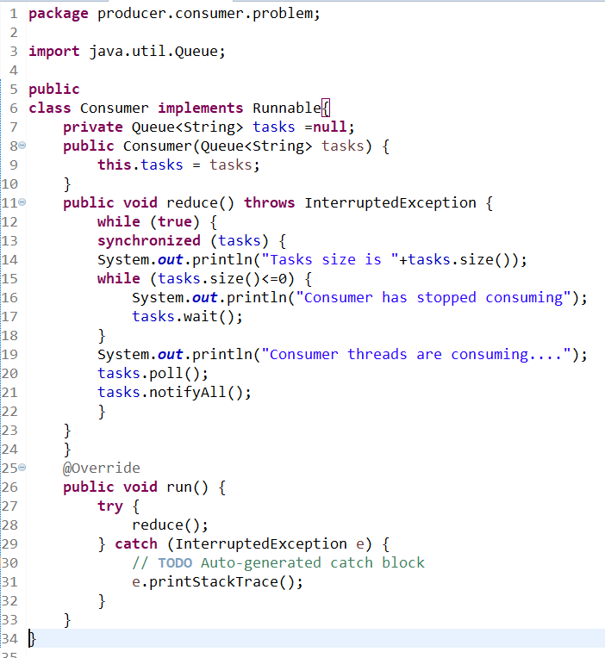

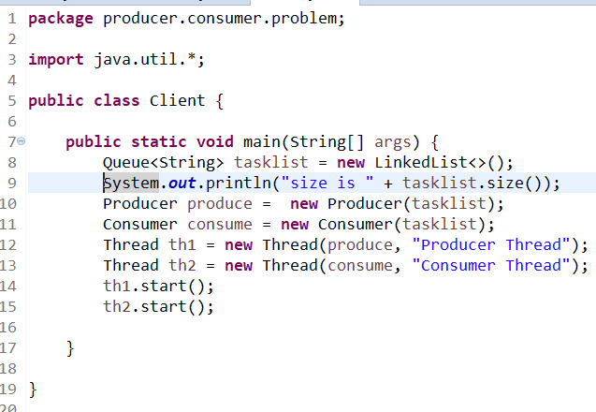

# Singleton Class

Only one instance can be created for singleton class. It can be achieved by doing below

* Create a private constructor
* Create a public static getInstance method to call this private constructor
* Put if condition in the getInstance method while creating the object only once.
* Then create the object like this
* MySingleTon m1 = MySingleTon.getInstance();

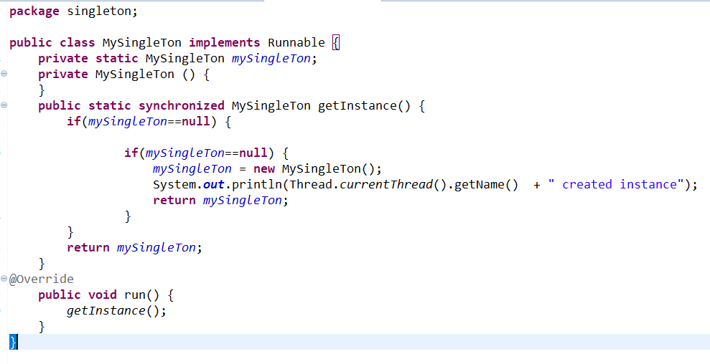

# Serialization

When we need to send object over the network, we need serialization.

In serialization process, we convert the object into file.ser file and in deserialization process we read it at another end.

To serialize any object, we make that class implement serializable interface.

Transient Variable: - If we don’t want to serialize any field, then make them transient.

**private transient String name;**

Java don’t write transient object into the .ser file, hence you cannot retrieve them.

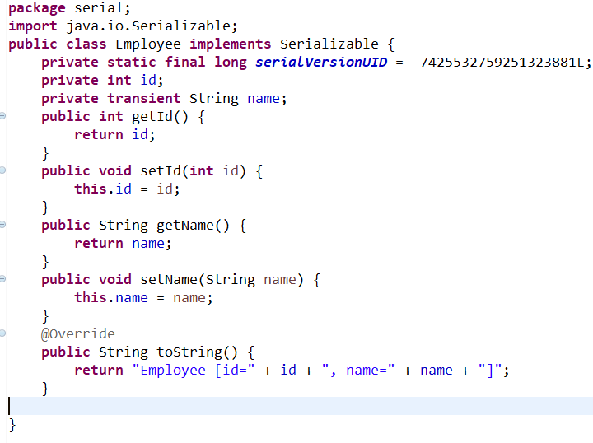

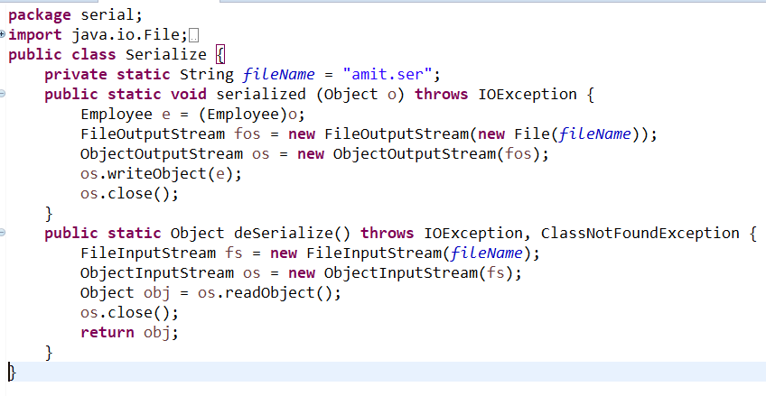

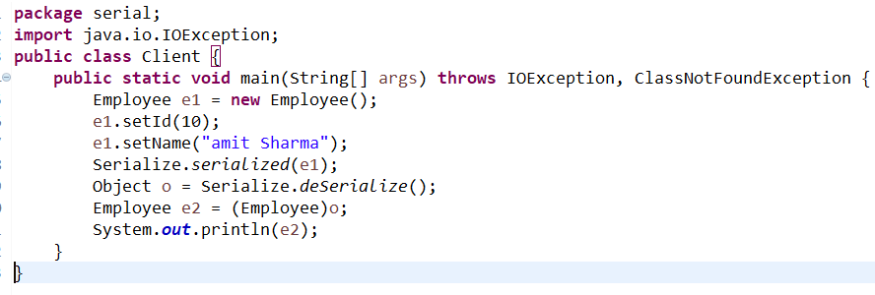

# Cloneable

**It means - Creating a new object with the same data**

This interface is used to clone the object. This is a marker interface like serializable and has got nothing inside it.

**StudentCloneExample newStudent = (StudentCloneExample) s1.clone();**

**Important** - When object is cloned, it takes the data from the object and creates a new object with different reference. Hence even If the original object is modified, it doesn’t impact the clone object.

Car c1 = new Car();

Car c2 = c1; // *here c2 is pointing to the same object location as c1 means they have the same reference. Hence if we change the c1, c2 will also change*.

Implementation - To implement it, first make the class implement the cloneable interface and override the object class clone method.

*public Object clone() throws CloneNotSupportedException {*

*return super.clone();*

*}*

## **There are 2 types of cloning – Shallow cloning and deep cloning.**

Shallow cloning – This is by default cloning. It clones at the high-level.

Deep cloning – It contains multiple layers of object. We need to implement our own login in clone method to achieve this. Below para is from the google article.

*Most of the time, clones are shallow copies. In other words, if the object being cloned contains a reference to another object A, then the clone contains a reference to the same object A, not to a clone of A. If this isn't the behavior you want, you can override clone() yourself.*

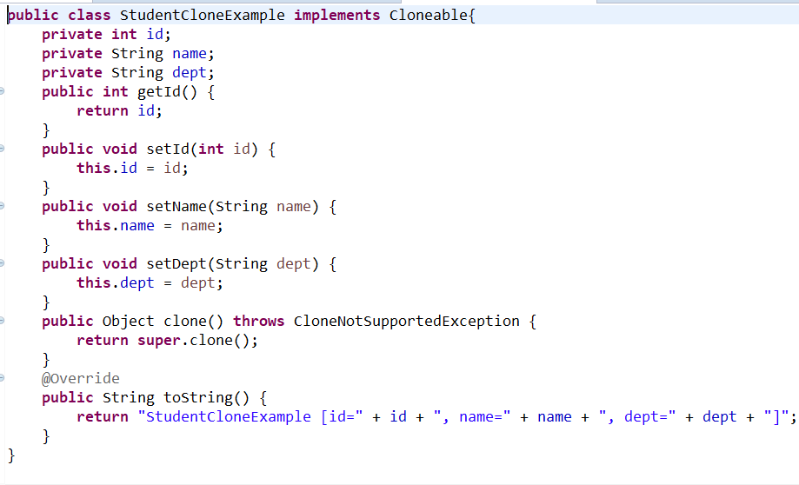

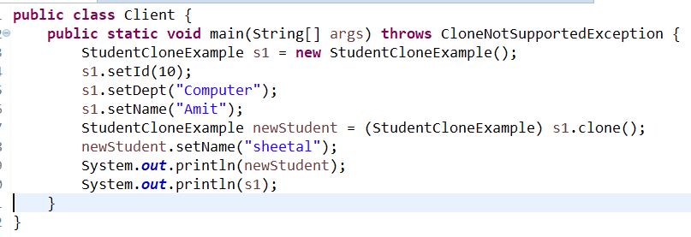

# JVM Internal Architecture

When we create some java file and do like javac hello.java, this creates the hello.class file.

And when java hello is excuted, it actually invokes the jvm like below to load the class file.



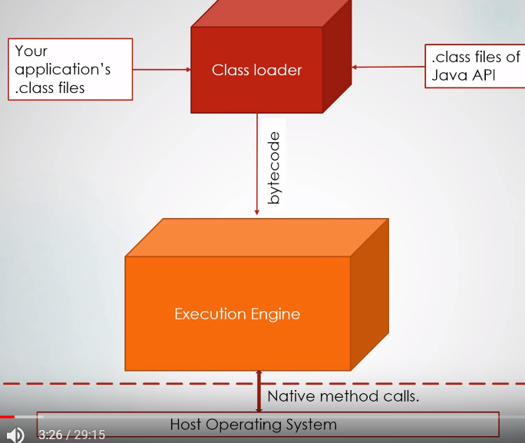

Below are the internal details at high level. This has got 3 main components

1. Class Loader subsystem-> BootStrap, Extention and application class loader
2. Runtime Data areas-> MethodArea, Heap, JavaStack, PC Register and Native method Stack
3. Execution Engine-> GC, Interpreter, JIT compiler and hotspot profiler

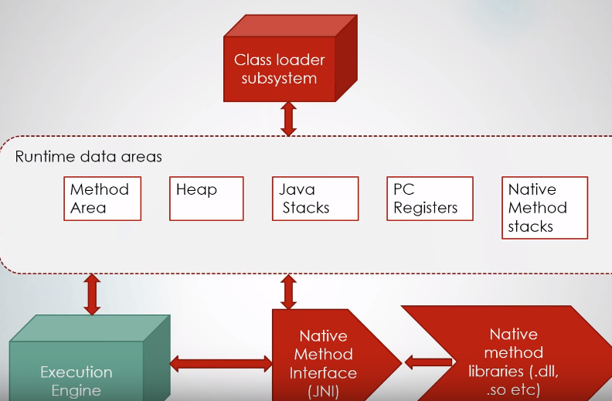

## Class Loader Subsystem

This is used to load the class. There are 3 sub category

**Load Phase**

**BootStrap Class loader** – This is responsible for loading java internal classes from the jar rt.jar.

**Extension Class Loader** - This is responsible for loading additional application jars. It load the jar from location jre/lib/ext path.

**Application Class Loader**-It loads class from specified in our environment class variables.

**Link Phase**

**Verify –** It check the bytecode given by class loader and check if it compatible with the JVM class specifications

**Prepare - Once** verified , here in this phase memory is allocated (to the default value)for only the static variables inside class file. Example – even if we have public static boleon **isexist=true**, it will still be set to its default value of **false** in prepare phase.

**Resolved –** here all the symbolic ref in the current class are resolved

**Initialize phase**

In this phase static variables, methods and blocks are initialized.Here, the actual initialization happens as in above example the **isexist** will be set to true here.

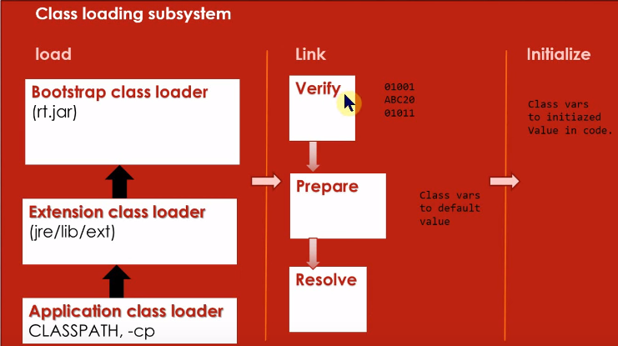

# RunTime Data Areas

**Method Area** – This is where the project class file goes. This is also called the **permgen** space.

If you have big project with lot of classed, and this space is too small(by default 64 mb is allocated to this space.) the it will throw

Java.lang.outofmemoryError: **PermGenSpace**

We can tune it with perameter -XX

In Java 8, it is now known as **metadata** where they have moved it to separate memory space in side host OS, to make sure it never runs out of memory.( In java 8 there is no limit for it to grow but we can still limit it with your own value)

**Heap Area** - This is where the objects reside. We can tune it with -Xms and -Xmx

# 

**PC Register** - This is telling about the next set of instructions for threads.

**Java Stack** – Anything which goes inside the method and local to it goes inside the stacks. If we have got 2 threads running a method, then they will form their own stack with their own copy of local variables.

Method calling goes in stacks on one another and resolved in LIFO manner until the main method executed and stacks go empty for next execution.

As these thread are separate from one another, hence this stack area is threadsafe

If this gets full , we get **StackOverFlow** error. We can tune it with -Xss

**Native Method Stack** - This area deals with native method calling like in some case you need to call the dll of window operating system. So, it basically to deal with the OS where this JVM is running.

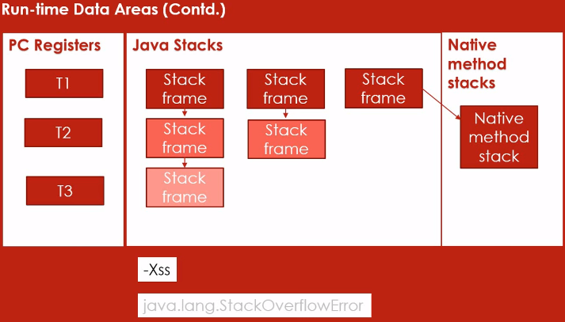

Execution Engine

Here the .class file or say byte code is fed to **interpreter which converts it to machine executable code** line by line.

**JIT** - If there are certain set of instruction which are repeated executed, then no need to interpret them every time as JIT keeps them to make the execution fast.

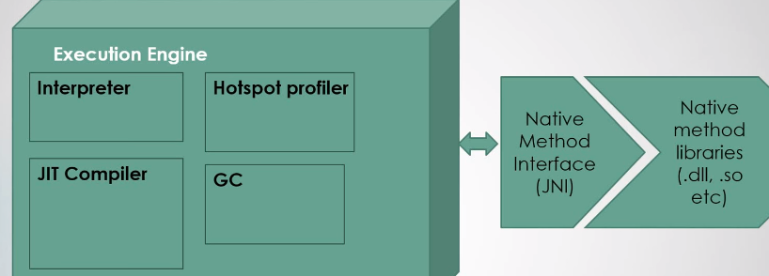

# Out of Memory (OOM)

Java Heap is made from below 3 spaces. JVM does this to do effective and easy garbage collection.

* Young generation
* Old Generation
* Perm Generation

## Young Generation

Java objects are stored in the "Young Generation" (a combination of the "Eden" / "From" / "To" spaces) Young generation look like below.

**PS Young Generation**

**Eden Space:**

capacity = 705167360 (672.5MB)

52.7369411993204% used

**From Space:**

capacity = 6029312 (5.75MB)

48.43298870584239% used

**To Space:**

capacity = 5767168 (5.5MB)

0.0% used

When you say "Object o = new Object()", that object initially resides in the Eden space of the young generation, and if it is short-lived it will be garbage collected without ever leaving this space. However, if it survives a few collection cycles in the Eden space,

it will travel through the To and From spaces and eventually be moved to the old generation, signifying that the garbage collector doesn't think it will become garbage soon. Notably, there is no guarantee on how often or how long the garbage collector will run, and it's common that "full" garbage collections (the ones that traverse all objects)

won't happen at all unless the young generation fills up most of the way.

## **Old and Perm(anent) Generation**

the "Old Generation"; the "Perm[anent] Generation" is where .class files are loaded.

## Increasing Heap without proper RCA

increase the heap size basically means ignoring the problem and places the burden on your OS's paging system, can result in very poor performance

# Fixing the obvious OutOfMemoryError cases0

## java.lang.OutOfMemoryError: Requested array size exceeds VM limit

If you get this, it means you've just tried to allocate an array that is so large it would consume all Java heap space, so in 99.9% of cases it's a bug in your code where you've incorrectly calculated the array size to allocate. In the very unlikely case that it's not a bug, you'll need to increase your maximum Java heap size by passing a higher value to the JVM's -Xmx argument (and probably buy a lot more RAM).

## java.lang.OutOfMemoryError: PermGen space

The Permanent Generation is where .class files with your Java bytecode are stored in memory. About 98% of the time, this error is really simple: if every time you start your program it quickly runs out of PermGen space, it means the code you're using for your project has become too large and you need to increase the maximum PermGen size to make room for it using the -XX:MaxPermSize=&lt;size&gt; JVM argument. To give you an idea of a reasonable limit, our PermGen size is about 82MB for a Java codebase with maybe 500 thousand lines of code and several dozen .jar libraries, and we cap the PermGen at a safe distance of 512MB to avoid being a nuisance but to still catch egregious PermGen space hogs.the graphical **VisualVM** tool for analyzing Java heap problems will be your best friend. It allows you to do many things, including breaking down the the PermGen contents by what type of object they are, or breaking down the .class files in the PermGen by the classloader that loaded them.

# Characterizing heap exhaustion

This is the broadest category of OutOfMemoryError issues, and as a result it's also one of the hardest to debug. There's a variety of error messages that might show up in this case, including:

* java.lang.OutOfMemoryError: Java heap space
* java.lang.OutOfMemoryError: GC overhead limit exceeded
* java.lang.OutOfMemoryError: &lt;reason&gt; &lt;stack trace&gt; (Native method)
* java.lang.OutOfMemoryError: request &lt;size&gt; bytes for &lt;reason&gt;. Out of swap space?
* The Java process was killed by a SIGSEGV signal (segfault).

The first two happen when you've overflowed the Java heap (or are about to because the garbage collector only freed 2% of the heap after stealing the processor for 98% of the runtime of your process)

Let's simplify by characterizing the three most common cases: when you have a heap that grows at a steady rate and eventually overflows, when you have a heap that's holding steady at some baseline and then overflows during a sudden flood of allocations, and when you have a heap whose baseline is higher than the maximum size.

## Steady growth

In the case where you have a heap growing at a roughly linear rate over time, usually it means that there is memory leak.it could be a real leak (in which case you should fix it by freeing the leaked memory), but in general I don't mean memory which nobody is referencing anymore. What I really mean are logical leaks: data structures that sometimes grow and never shrink.

## Explosive growth

If your heap has reached a roughly stable size but then suddenly fills due to a very large group of allocations, this usually is a result of receiving unexpectedly large input. Like all growing companies, as our customers have put more data into our systems we've hit a couple of bugs of this nature where we do a database query that unexpectedly returns, say, 100-1000x the number of rows we expected

Not only does this tie up the database for a good long time fetching all the data, but once it hands the data to the JVM there's no possible way Java can hold it all in memory. The same basic problem has been seen when reading large files into memory as well. If you're only using a small subset of the data you're reading, the obvious workaround is to only read in what's necessary.

Identifying the problem after there's explosive growth is usually not very difficult because your heap will be chock-full of one object type allocated from one code path, and the thread that runs out of memory is usually also the one which is allocating it like crazy.

## Baseline is higher than maximum size

This case is relatively difficult to identify but very easy to deal with. Once you've ruled out that you're neither dealing with a leak or a flood, and especially if you start running out of memory during many different but equally pedestrian workloads, you're probably dealing with this case. This is by far the best reason to expand the heap size because it means that your program's working set has simply grown beyond the bounds you set for it.

# Java heap debugging

My favorite tool for debugging the Java heap is VisualVM (mentioned above). It allows you to break down the heap by Java object type, view the object reference tree to see what objects are pinning the most memory, and browse other pre-built metrics. The pre-built metrics are enough for most cases, but VisualVM's truly killer feature is the object query language, which allows you to run SQL-like queries over the entire heap to collect specific metrics about each object that might help you debug your problem.

# Prerequisite to debug OOM

* Java Visual VM
* Collect Java heap dumps when OutOfMemoryErrors occur. To turn these on you should use -XX:+HeapDumpOnOutOfMemoryError and related options.
* To tell what happened when the JVM dies because of a fatal error, dump an error file using the -XX:ErrorFile=/path/to/errfile.log JVM option.
* Dump a core file when your JVM segfaults. This is highly OS-dependent, so look up the relevant documentation for your OS
* Logs of when your JVM starts, stops, restarts, crashes
* Garbage collection logging with the -XX:PrintGC JVM family of arguments.
* Moderately detailed logs of what general activity your application was doing.

# How can we avoid OOM in production

* The most important lesson: never use different garbage collection or memory settings in development than you use in production. More specifically:
* Don't use the -client JVM option in development and the -server option in production.
* Don't use a 32-bit JVM in development and 64-bit JVM in production.
* Don't switch garbage collectors, garbage collection tuning, or heap maximums between development and production.
* Don't switch OSes or JVMs between development and production.
* When your development machine or a production system creates core files, Java heap dumps, or fatal error files, surface them so that you don't accidentally ignore them.

# Heap and Stack memory allocation

Following three JVM options are used to specify initial and max heap size and thread stack size while running Java programs.

-Xms set initial Java heap size

-Xmx set maximum Java heap size

-Xss> set java thread stack size

**Reference** - <https://www.delphix.com/blog/data-virtualization/defanging-outofmemoryerror>

# String, StringBuilder and StringBuffer

## String -

Thread and immutable. Means once initialize, it cannot be changed.

String a = “amit”;

String a = “amit ”+”sharma” /// here amit and sharma will be considered 2 object concat.

## StringBuilder

**No threadsafe** but mutable(changeable) data structure

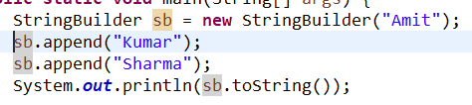

## StringBuffer

**Threadsafe** and mutable also.

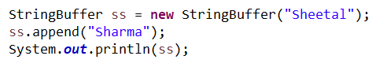

# Annotation

They are used to make sure we catch the problems at compile time.

Example @Override annotation is used to make sure that same method is present in the superclass also. Otherwise it will throw error

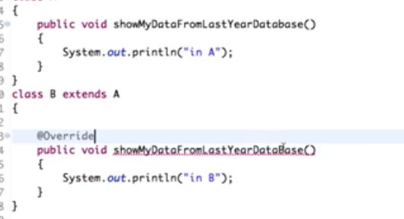

Example @Deprecated

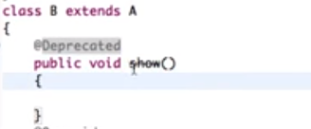

# Enum

This is used to define the constants and ranges. Previously we used to use static final variables in interfaces for this purpose. Switch Example – These constants considered as objects in Enum but can be called using classname.

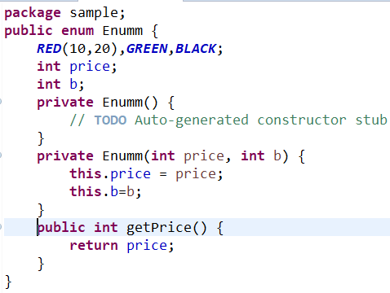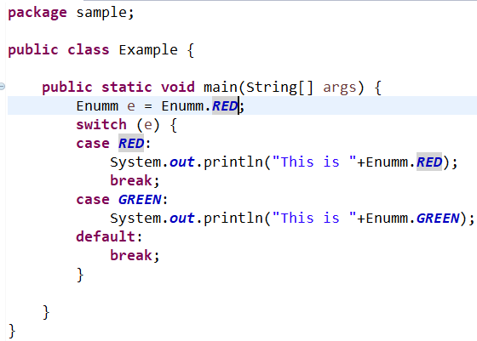

# Lambda expression

To create a lambda expression, we specify input parameters (if there are any) on the left side of the lambda operator -> and place the expression or block of statements on the right side of lambda operator. For example, the lambda expression (x, y) -> x + y specifies that lambda expression takes two arguments x and y and returns the sum of these.

**Advantage of Lambda Expression**

Main advantage is when it comes to multithreading, with the help of parallel Stream API lambda expression can process the collection parallelly.

### **A lambda expression in Java has these main parts:**

Lambda expression only has body and parameter list.

1. No name – function is anonymous, so we don’t care about the name

2. Parameter list

3. Body – This is the main part of the function.

4. No return type – The java 8 compiler can infer the return type by checking the code. you need not to mention it explicitly.

To use lambda expression, you need to either create your own functional interface or use the pre-defined functional interface provided by Java. An interface with only single abstract method is called functional interface (or Single Abstract method interface), for example: Runnable, callable, ActionListener etc.

## Example 1: With Parameter

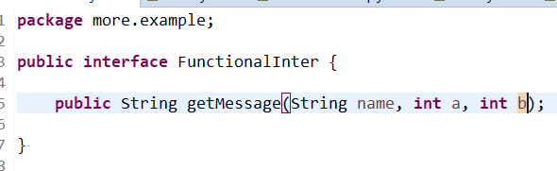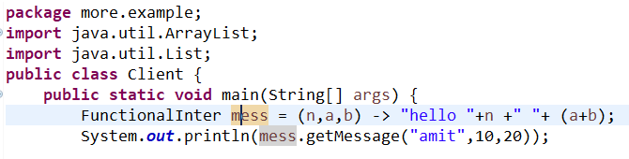

## Example 2: Without Parameter

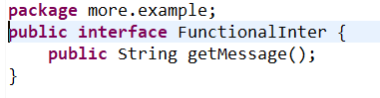

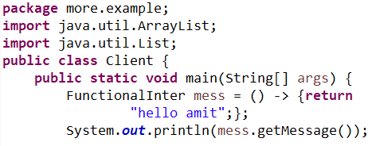

## Examples 3: For Each usage

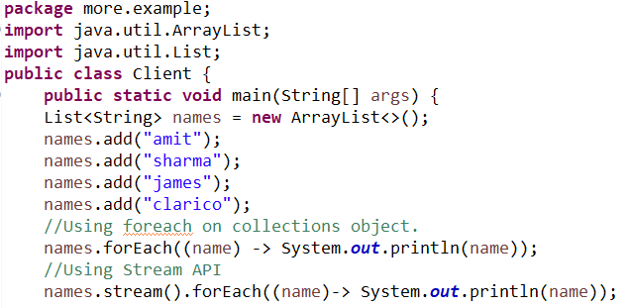

## Example 4- Iterating Map using Lambda Expression

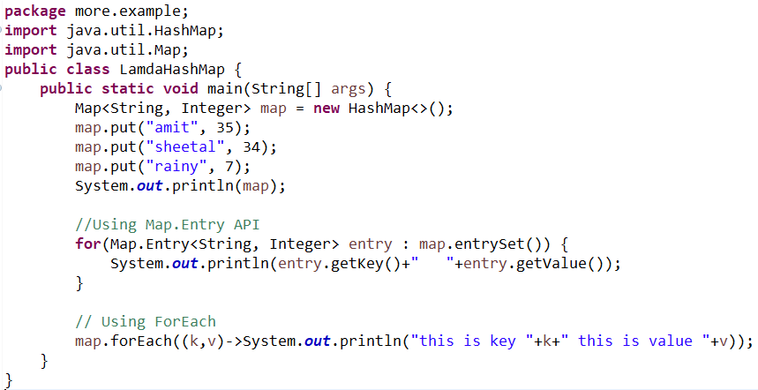

# Difference between class not found exception and noclassdeffounderror in java

**Class Not Found Exception** – This is runtime exception which usually occurs with you try to load a class from class path which is not there. Example – Connecting to the DB

throw ClassNotFoundException if the mentioned class **“oracle.jdbc.driver.OracleDriver”** is not found in the classpath.

**NoClassDefFoundError –** This occurs when JRE tries to load the class definition which was present at compile time but not at run time

**Example** If you are using A.class and B.class and both uses each other and at runtime you delete one of them.